# PeopleSafe - Viewing Activity in PeopleSafe and Compass Interactions

Process

Related Documents

**Description:** Navigating the View Activityscreen located in PeopleSafe that includes information about our contact with a member and the actions taken.

|  |
| --- |
| Process |

The information on this is captured from the following sources:

* PeopleSafe
* Messaging Platform (MP)
* Member Portal (.com)
* Interactive Voice Response (IVR) System
* RxClaim

This information provides a timeline for the member’s various interactions with our Home Delivery.

|  |  |
| --- | --- |
| **Step** | **Action** |
| **1** | From the **Main Screen**, click the **View Activity** button.    Icon - Important InformationIf clicking **View Activity** results in a pop-up box reading “No records retrieved on search,” this may be due to a database error, or it may mean that the member has not called in before. Click **OK** to clear the notification. |
| **2** | Review recent activity.     * **Start Date:** The date the activity was initiated. * **Start Time:** The time (Central Time) the activity was initiated. * **End Date:** The date the activity ended / agent logged out of the PeopleSafe record. * **End Time:** The time (CT) the activity ended / agent logged out of the PeopleSafe record. * **Created by:** Name of agent who accessed PeopleSafe. * **Activity:** Actions performed while in the PeopleSafe account (See Step 3). * **Tasks:** Resolution Manager Tasks will display as a hyperlink. * **Contact Duration (mm:ss):** The total time of the call. * **Activity Notes:** Call notes manually entered by the Agent will display as a hyperlink. Click this hyperlink to expand notes. |
| **3** | Click the **Expand All** button to view the Activity log in greater detail.  **Result:** This displays a complete list of actions taken by the CCR while accessing the PeopleSafe file. Most of this data is recorded when the CCR clicks the **Capture Activity** button while closing the call.     * Refer to Activity Details Example at the end of this document for more information on how to read the records found on this screen.   **Tips:**   * Click the **Collapse All** button to return to the main record. * Clear the page by clicking the **Clear** button. Data can be refreshed by going back to the Main Screen and accessing View Activity again. |
| **4** | Click the **View CRM Interaction** button to view activities performed in Compass (bottom of screen). It displays detailed information about the member contact that was input into Compass (See field descriptions below).  **Note:** If no Compass interactions exist, it displays “No interaction found.”         * **Case Opened Date:** Date the case was opened. * **Case Opened Time:** Time the case was opened. * **Case Closed Date:** Date the case was closed. * **Case Close Time:** Time the case was closed. * **Contact Duration:** Time user had the member’s account open. * **Case Number:** The record number used for tracking interaction with a member. This hyperlink field is not used. * **Service Requests:** Activities performed by the user. * **Primary Interaction Reason:** Reason for the call as stated by the member. * **Additonal Interaction Reason:** Additional reasons for the call. * **Support Task Type:** Displays if a support task (RM Task) was opened. Click on the hyperlink to view the Task Details.   **Example:** Below image of what the user will see after clicking the hyperlink.     * **Case Notes:** Notes input by the user accessing the member’s profile (case) in Compass.   **Note:** Click on the hyperlink in Case Notes hyperlinks to display a pop up screen for an easier to read format. |
| **5** | 1. Click the **Enterprise Interactions** button.   **Result:** Enterprise Interactionsscreen displays. This is a repository of basic "contacts" callers have had with us across various channels. This may include but is not limited to: IVR, Portal, Care, Retail, LINKS and/or Specialty interactions.    **Example:** Enterprise Interactions screen.     1. Click the **Back** button to return to the main record. |

**Activity Details Example:** Resume Refill w/Rx Preserved: 0 (Zero means no)

An inbound call is received where the member has started out with the automated system to place an order. One or more of the prescriptions were out of refills and they requested to speak to a CCR for assistance. The Rx was not copied to the Order Placement screen.

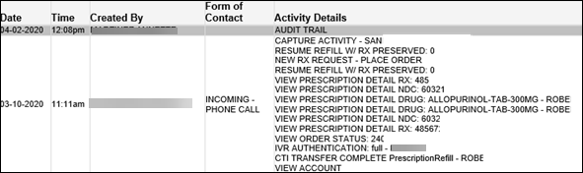

**Activity Details Example:** Resume Refill w/Rx Preserved: 1 (One means yes)

An inbound call is received where the member has started out with the automated system to place an order for multiple Rx’s. One or more of the prescriptions were out of refills and they requested to speak to a CCR for assistance. The one Rx was copied to the Order Placement screen for completion by the representative.

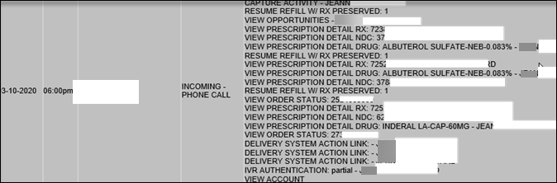

Top of the Document

|  |
| --- |
| Related Documents |

[Log Activity/Capture Activity Codes (005164)](https://thesource.cvshealth.com/nuxeo/thesource/#!/view?docid=bdac0c67-5fee-47ba-a3aa-aab84900cf78)

[Customer Care Abbreviations, Definitions and Terms Index (017428)](https://thesource.cvshealth.com/nuxeo/thesource/#!/view?docid=c1f1028b-e42c-4b4f-a4cf-cc0b42c91606)

**Parent Document:** [CALL-0049 Customer Care Internal and External Call Handling](https://policy.corp.cvscaremark.com/pnp/faces/DocRenderer?documentId=CALL-0049)

Top of the Document

Not to Be Reproduced or Disclosed to Others without Prior Written Approval

**ELECTRONIC DATA = OFFICIAL VERSION / PAPER COPY = INFORMATIONAL ONLY**